WEEK 1 TASK
Data Science Project Planning and Strategy Design
Hypothetical Project: Customer Churn Prediction using Python

Internship / Task | Yuva Intern – Data Science
Week | Week 1
Project Type | Hypothetical / Planning Stage
Primary Technology | Python and standard data science libraries

1. Introduction and Project Background
This report presents a complete project plan and strategy for a hypothetical data science project focused on predicting customer churn. Customer churn occurs when customers stop using a service or cancel a subscription. For many organizations, identifying customers who are likely to leave can support timely retention activities. The proposed project uses Python-based data science methods to transform customer information into useful analytical insights and a predictive model.
The Week 1 task is intentionally focused on conceptualization and planning rather than implementation. No real dataset is required at this stage. The objective is to define the problem, expected data, workflow, tools, methodology, timeline, evaluation strategy, risks, and expected outcomes before technical development begins.

2. Problem Statement and Motivation
The hypothetical organization has historical customer records containing information such as customer tenure, service usage, subscription type, billing information, support interactions, and previous churn status. The organization wants to understand the factors associated with churn and develop a model that can estimate the likelihood of future churn.
The motivation is to move from reactive decision-making to data-driven planning. Instead of waiting for customers to leave, the organization could use model outputs as one input for targeted retention analysis. The project also aims to identify important behavioral and service-related patterns that can guide business teams.

3. Project Objectives
- Define a clear and measurable customer churn prediction problem.
- Identify appropriate structured data sources and required variables.
- Plan data cleaning, validation, transformation, and exploratory analysis.
- Design a feature engineering strategy suitable for churn prediction.
- Compare suitable classification approaches such as Logistic Regression, Decision Tree, Random Forest, and gradient-boosting methods.
- Define evaluation metrics that address class imbalance and business needs, including precision, recall, F1-score, ROC-AUC, and confusion matrix.
- Document assumptions, risks, limitations, and mitigation strategies.
- Produce a reproducible Python-based project structure that can be implemented in later weeks.

4. Project Scope

4.1 In Scope
- Problem definition and requirement analysis.
- Planning of customer data collection or acquisition.
- Data quality checks, missing-value handling, duplicate detection, and outlier review.
- Exploratory data analysis and visualization.
- Feature engineering and preprocessing design.
- Supervised binary classification model planning.
- Model validation and performance evaluation.
- Interpretation of important features and preparation of a final report.

4.2 Out of Scope
- Real-time production deployment during Week 1.
- Automated customer messaging or retention campaigns.
- Collection of personally identifiable information beyond what is necessary for analysis.
- Guaranteeing that model predictions will change customer behavior.
- Replacing business decisions with automated predictions.

5. Proposed Methodology and Strategy
The project will follow a structured data science lifecycle. Each stage will have defined inputs, activities, quality checks, and outputs. The workflow is designed so that decisions made in one stage can be reviewed before moving to the next stage.
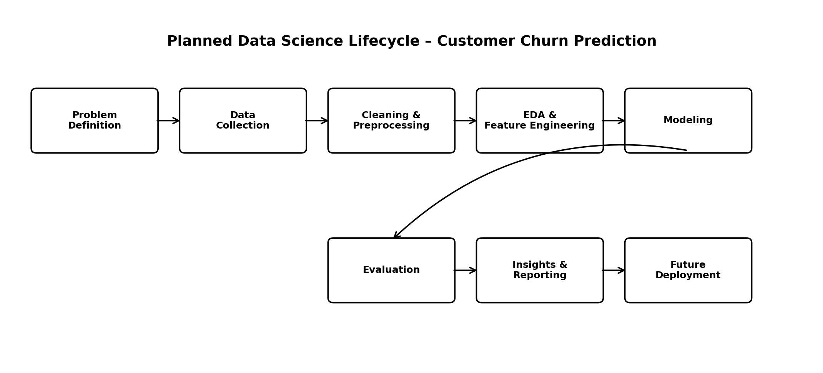
Figure 1. Planned end-to-end data science workflow

5.1 Data Collection Strategy
Potential sources include anonymized customer master records, subscription and billing records, product usage logs, customer-support interactions, and historical churn labels. The final data dictionary should define each field, its data type, valid range, business meaning, and whether it is available before the prediction point.

5.2 Data Cleaning and Preprocessing
- Inspect schema, data types, duplicate records, missing values, and inconsistent categories.
- Standardize categorical labels and date formats.
- Handle missing values using methods appropriate to the variable and business meaning.
- Check numerical ranges and investigate potential outliers rather than removing them automatically.
- Avoid data leakage by ensuring that features are known before the prediction time.
- Encode categorical variables and scale numerical variables when required by the selected model.

5.3 Exploratory Data Analysis
EDA will examine churn distribution, customer tenure, usage patterns, subscription type, payment behavior, support interactions, and relationships between candidate variables and the target. Planned visualizations include bar charts, histograms, box plots, correlation views, and churn-rate comparisons across relevant groups.

5.4 Feature Engineering
- Tenure bands and normalized usage measures.
- Recent activity and changes in usage where timestamps are available.
- Support-contact frequency and recency.
- Payment or billing behavior indicators.
- Aggregated customer-level statistics calculated only from information available before prediction.

5.5 Modeling Strategy
The first baseline will use Logistic Regression because it is interpretable and provides a useful reference point. Tree-based approaches such as Decision Tree and Random Forest will then be considered for non-linear relationships. If appropriate, a gradient-boosting model may be evaluated. Model selection will not be based only on one metric; interpretability, validation performance, class imbalance, and practical usefulness will also be documented.

5.6 Evaluation Strategy
Metric | Purpose
Accuracy | Overall proportion of correct classifications; interpreted carefully if churn classes are imbalanced.
Precision | Proportion of predicted churn cases that are actually churn cases.
Recall | Proportion of actual churn cases that the model successfully identifies.
F1-score | Harmonic mean of precision and recall; useful when both are important.
ROC-AUC | Measures ranking/discrimination ability across classification thresholds.
Confusion Matrix | Shows true positives, true negatives, false positives, and false negatives.

6. Tools and Python Libraries
Tool / Library | Planned Use
Python | Primary programming language for data analysis and modeling.
Jupyter Notebook / JupyterLab | Interactive experimentation, documentation, and visualization.
NumPy | Numerical operations and array-based computation.
Pandas | Data loading, cleaning, transformation, and tabular analysis.
Matplotlib | Core plotting and visualization.
Seaborn | Statistical visualization and exploratory charts.
Scikit-learn | Preprocessing, model training, validation, metrics, and pipelines.
Git / GitHub | Version control, project organization, and reproducibility.

7. Project Architecture and File Structure
A modular structure will be used so that data preparation, analysis, modeling, and reporting can be maintained separately. A proposed structure is:
customer-churn-project/
├── data/
│ ├── raw/
│ └── processed/
├── notebooks/
│ ├── 01_data_quality.ipynb
│ ├── 02_eda.ipynb
│ └── 03_modeling.ipynb
├── src/
│ ├── preprocessing.py
│ ├── features.py
│ ├── models.py
│ └── evaluation.py
├── reports/
├── requirements.txt
├── README.md
└── .gitignore

8. Work Timeline – 30–35 Hours
The Week 1 plan allocates approximately 31 hours. The schedule is designed to leave sufficient time for planning, review, documentation, and correction rather than concentrating all effort on technical modeling.
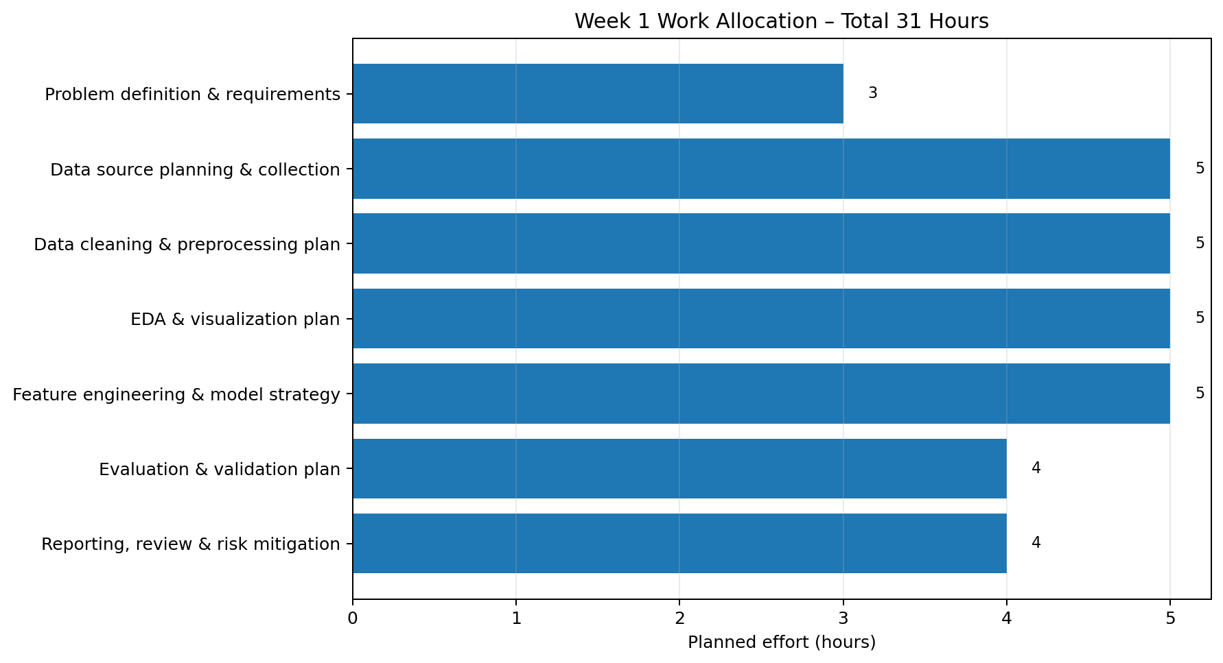
Figure 2. Planned Week 1 effort allocation
Phase | Activity | Hours
1 | Problem definition & requirements | 3
2 | Data source planning & collection strategy | 5
3 | Data cleaning & preprocessing plan | 5
4 | EDA & visualization plan | 5
5 | Feature engineering & model strategy | 5
6 | Evaluation & validation plan | 4
7 | Reporting, review & risk mitigation | 4

9. Expected Outcomes
- A clearly defined customer churn prediction problem and success criteria.
- A documented data dictionary and data-quality checklist to guide later implementation.
- A complete Python-oriented data science workflow from data ingestion to evaluation.
- A reproducible project structure suitable for GitHub.
- A model evaluation framework that considers multiple classification metrics.
- Actionable analytical questions and hypotheses for later technical tasks.
- A final Week 1 planning report containing diagrams, timeline, tools, risks, and mitigation strategies.

10. Anticipated Challenges and Mitigation Strategies
Challenge | Mitigation Strategy
Missing or inconsistent data | Profile missingness, document causes, and choose variable-specific treatment methods.
Class imbalance | Use appropriate metrics, stratified validation, and class-weighting or resampling when justified.
Data leakage | Define a prediction timestamp and ensure features are available before that timestamp.
Overfitting | Use train/validation/test separation or cross-validation and keep the feature/model pipeline reproducible.
Poor interpretability | Include interpretable baseline models and feature-importance or explanation techniques where appropriate.
Changing customer behavior | Document the time period of the data and plan periodic model monitoring in later stages.
Privacy concerns | Use anonymized data, minimize sensitive fields, and restrict access to necessary information.

11. Quality and Success Criteria
- The report clearly defines the problem, objectives, scope, methodology, timeline, tools, and expected outcomes.
- The proposed workflow is logically ordered and technically feasible.
- Data leakage, class imbalance, privacy, and reproducibility are explicitly considered.
- The evaluation strategy uses metrics appropriate for binary classification rather than relying only on accuracy.
- The project plan can be translated into implementation tasks in later weeks.
- All diagrams and tables are readable and directly support the planning process.

12. GitHub Project URL
GitHub repository: To be added before submission. Once the project repository is created, paste its URL into the Yuva Intern submission form. For a technical/software-related task, the internship instructions indicate that the project GitHub URL should be provided.

13. Week 1 Report Description for Submission
This Week 1 Data Science report presents a comprehensive project plan and strategy for a hypothetical Customer Churn Prediction project using Python. The report begins by defining the business problem and explaining why data-driven churn analysis can be useful for understanding customer behavior. It then establishes clear project objectives and separates the activities that are within scope from those that are outside the scope of the first phase. A complete data science methodology is proposed, covering data source planning, data quality checks, cleaning, preprocessing, exploratory data analysis, feature engineering, model selection, validation, and evaluation. The plan considers baseline and tree-based classification models and specifies appropriate evaluation metrics including precision, recall, F1-score, ROC-AUC, and the confusion matrix. The report also identifies the Python libraries and development tools expected to support the project, including Pandas, NumPy, Matplotlib, Seaborn, Scikit-learn, Jupyter, Git, and GitHub. Strategic diagrams illustrate the end-to-end workflow, while a 31-hour work allocation provides a practical Week 1 timeline. Potential challenges such as missing data, class imbalance, data leakage, overfitting, privacy, and changing customer behavior are documented with mitigation strategies. Since this is a planning task, no real dataset or production model is required. The expected result is a structured, reproducible blueprint that can be implemented in subsequent technical tasks. The report is designed to demonstrate understanding of the data science lifecycle, logical project planning, technical strategy, risk awareness, and professional documentation.

14. Conclusion
This Week 1 plan establishes a practical foundation for a complete data science project. By defining the problem before implementation, specifying the data requirements, planning quality checks, selecting appropriate analytical methods, and allocating time across the project lifecycle, the proposed approach reduces avoidable rework and supports reproducibility. The next phase can use this blueprint to work with an actual dataset, implement the planned preprocessing and EDA steps, train baseline models, and evaluate the results against the documented criteria.

